Chapter 5: The Traditional Strategy: Wong, Gong, and Hands that Evaluate to a Number
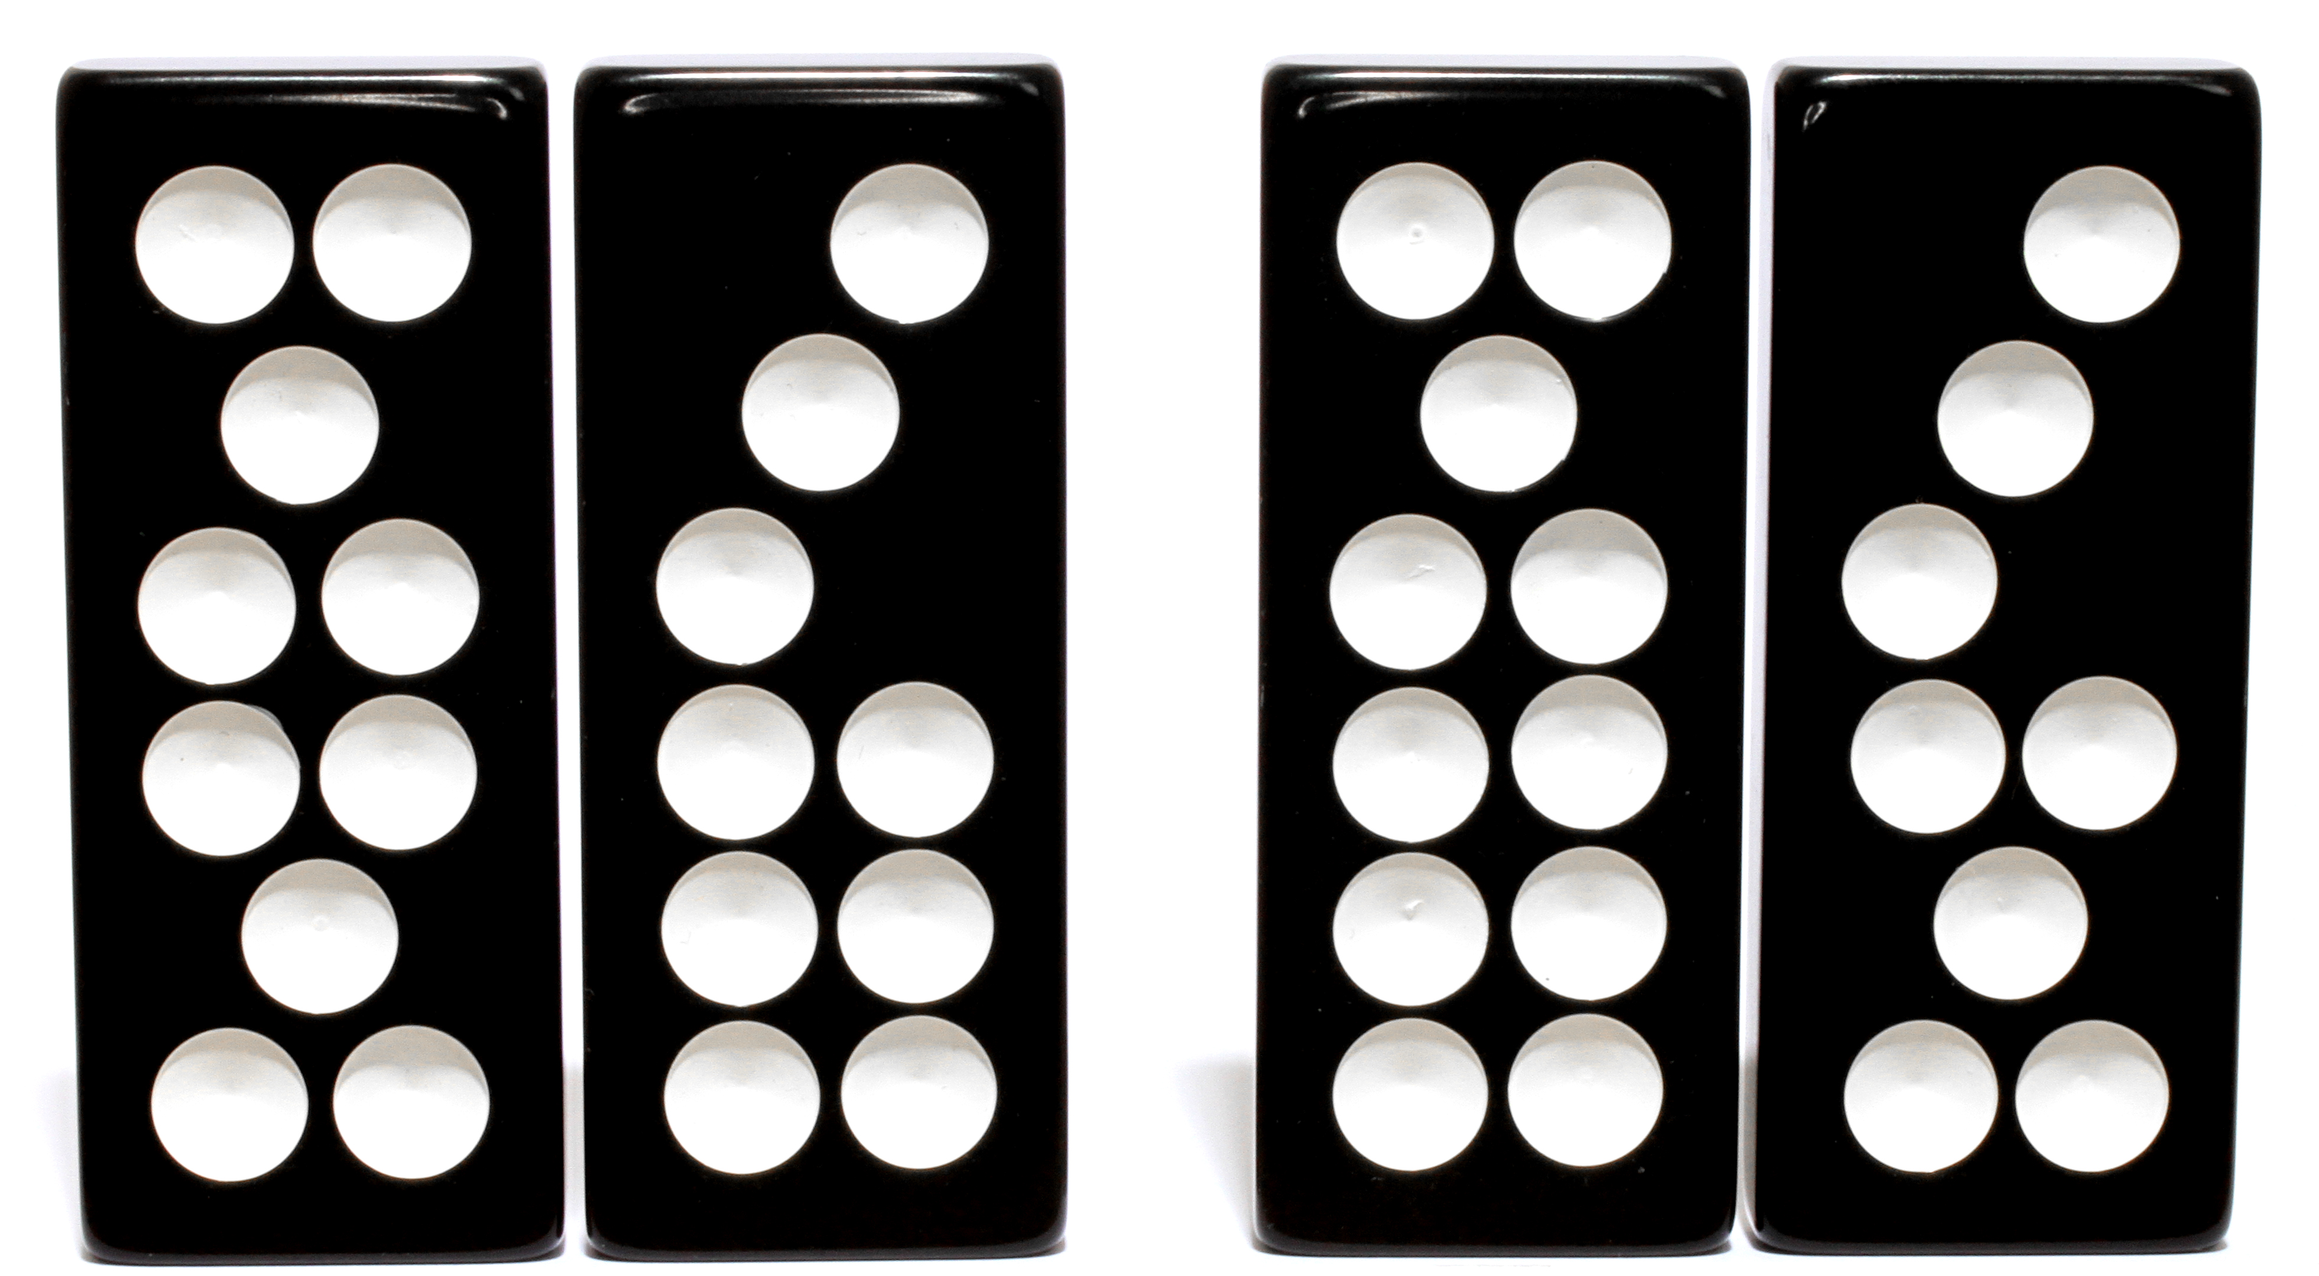
What’s special about this deal?
See the last page of this chapter for the answer.
Now that you can read the value of a two-tile hand, and you can recognize the three divisions of any four-tile deal, you are ready to learn the traditional strategy..
When you are dealt four tiles, the only decision you have to make is how will you divide those tiles into a high hand and a low hand? Having a strategy of play means knowing how you will divide any set of four tiles that you are dealt.
The traditional strategy has been developed over countless years of Pai Gow players observing what works and what doesn’t work. The traditional strategy is an excellent strategy, and it is used by almost all Pai Gow players and casinos. This section of the book will teach you the traditional strategy.
You will learn the entire traditional strategy, one easy step at a time. I use many example deals, spiced with explanations and cool statistics. The explanations will help you remember the strategy, because rather than rote memorization, the strategy will make beautiful sense to you.
Not only will the strategy be easier to learn than other presentations you may have seen, but you will know how to play every single deal that you can receive, with no uncertainty or ambiguity.
You should read Chapter 4, “Naming the Divisions,” before you read this chapter. Chapter 4 teaches you some new terminology that you’ll need in order to learn the traditional strategy in the easy and logical way I present it here. Experienced players may save time by reading a briefer presentation of that new terminology in Appendix B.

nine four  xzw06-13-01-04xzw  06 Mooy 13 Chop Gow 01 Gee Joon 04 Yun  eight five  xzw06-04-13-01xzw  06 Mooy 04 Yun 13 Chop Gow 01 Gee Joon  seven six  xzw13-04-06-01xzw  13 Chop Gow 04 Yun 06 Mooy 01 Gee Joon | Before we embark on learning the traditional strategy, there are two more pieces of vocabulary that you need to know. For any four tiles you are dealt, you must be able to identify:  - the most valuable high hand, and  - the most valuable low hand.  As you know from Chapter 4, “Naming the Divisions,” the three possible divisions of the four tiles at left are called, from top to bottom, the Best High division, the Alternate division, and the Best Low division. The way the tiles are arranged, each division has its high hand on the left and its low hand on the right. The top division’s high hand has value nine, the middle division’s high hand has value eight, and the bottom division’s high hand has value seven. For these four tiles, the most valuable high hand is nine.  The most valuable high hand is simply the value of the high hand in the division that has the most powerful high hand. It’s the most valuable two-tile hand that you can make with these four tiles.  Now look at the low hands of the three divisions: they have value four, five and six. The most valuable low hand of this deal is six, because six is the value of the low hand in the division that has the most powerful low hand. It’s the most powerful low hand that you can make.

five one  xzw04-15-07-16xzw  04 Yun 15 Chop Chit 07 Chong 16 Chop Ng  three three  xzw04-16-07-15xzw  04 Yun 16 Chop Ng 07 Chong 15 Chop Chit  four two  xzw04-07-15-16xzw  04 Yun 07 Chong 15 Chop Chit 16 Chop Ng | If you were dealt these four tiles, you would have a most valuable high hand of five, and a most valuable low hand of three.

seven four  xzw06-15-04-01xzw  06 Mooy 15 Chop Chit 04 Yun 01 Gee Joon  eight three  xzw04-06-01-15xzw  04 Yun 06 Mooy 01 Gee Joon 15 Chop Chit  six five  xzw06-01-04-15xzw  06 Mooy 01 Gee Joon 04 Yun 15 Chop Chit | On this page’s deal, the most valuable high hand is eight, and the most valuable low hand is five. You’ll see that the most valuable high hand is the high hand in the Best High division of the tiles, and the most valuable low hand is the value of the low hand in the Best Low division.

four one  xzw13-16-08-11xzw  13 Chop Gow 16 Chop Ng 08 Bon 11 Tit  nine six  xzw08-16-11-13xzw  08 Bon 16 Chop Ng 11 Tit 13 Chop Gow  three two  xzw08-13-11-16xzw  08 Bon 13 Chop Gow 11 Tit 16 Chop Ng | The Traditional Strategy  Rule #1: If you are dealt four tiles that contain an Only Acceptable division, play that division.  You will be dealt tiles that contain an Only Acceptable division 33.4% of the time, almost exactly one deal in three.  The tiles on this page contain an Only Acceptable division, the middle division.  If your tiles do not contain an Only Acceptable division, they will contain a Best High division and a Best Low division, and you will need to select one of those two divisions to play. But it’s always correct to play an Only Acceptable division if you have one. You now know how to play one-third of the deals that you will receive!

five one  xzw04-15-07-16xzw  04 Yun 15 Chop Chit 07 Chong 16 Chop Ng  three three  xzw04-16-07-15xzw  04 Yun 16 Chop Ng 07 Chong 15 Chop Chit  four two  xzw04-07-15-16xzw  04 Yun 07 Chong 15 Chop Chit 16 Chop Ng | The next rule covers deals that only allow you to make very weak hands.  Rule #2: If your deal has a most valuable high hand of value three, four, five, or six, then play the Best Low division of your tiles.  The deal at left has a most valuable high hand of value five. According to Rule #2, you play these tiles by using the Best Low division, which is the middle division, maximizing the value of your low hand. Note that you found the most valuable high hand in the top division, but you play the middle division, because the rule dictates that you play the Best Low division.  You will be dealt tiles that have a most valuable high hand of 3, 4, 5, or 6 once every sixteen deals. There are 141 different deals in Pai Gow that fit into this rule, and this one simple rule tells you how to play all 141 of those deals: play the Best Low division.  We’ll discuss why the Best Low division is the most advantageous for you to play with these deals a little later in this chapter.

